

**American International University- Bangladesh**

**CSC 2209: Object Oriented Programming 1 (JAVA)**

**CO1 Evaluation**

**Project Summary Report**

**Summer 18-19**

**Group No: 2**

**Project Title: University Management System**

|  |  |
| --- | --- |
| Student Name | Student Id |
| Md Ashikur Rahman | **18-38519-2** |
|  |  |
|  |  |

**Introduction:**

*Write the answer of why you are doing this project? (No more than 60 words)*

**User Category:**

There are three types of Users here. They are:

* Student
* Teacher
* Admin

**Feature List:**

In this project the “User Type 1” has the following features:

* Log in with user id and password
* Get class Routine
* .Edit own profile
* Previous semester result
* Next semester pre registration sequentially by pre-requisite

In this project the “User Type 2” has the following features:

* Get all the students
* Get Students info
* Upload their marks

In this project the “User Type 3” has the following features:

* Add,Delete user
* Modify permissions

In this project the “User Type 4” has the following features:

* Have controls of time
* Sets when the semester is about to end so registration gets open for students
* Ability to lock grade

**GUI Description:**

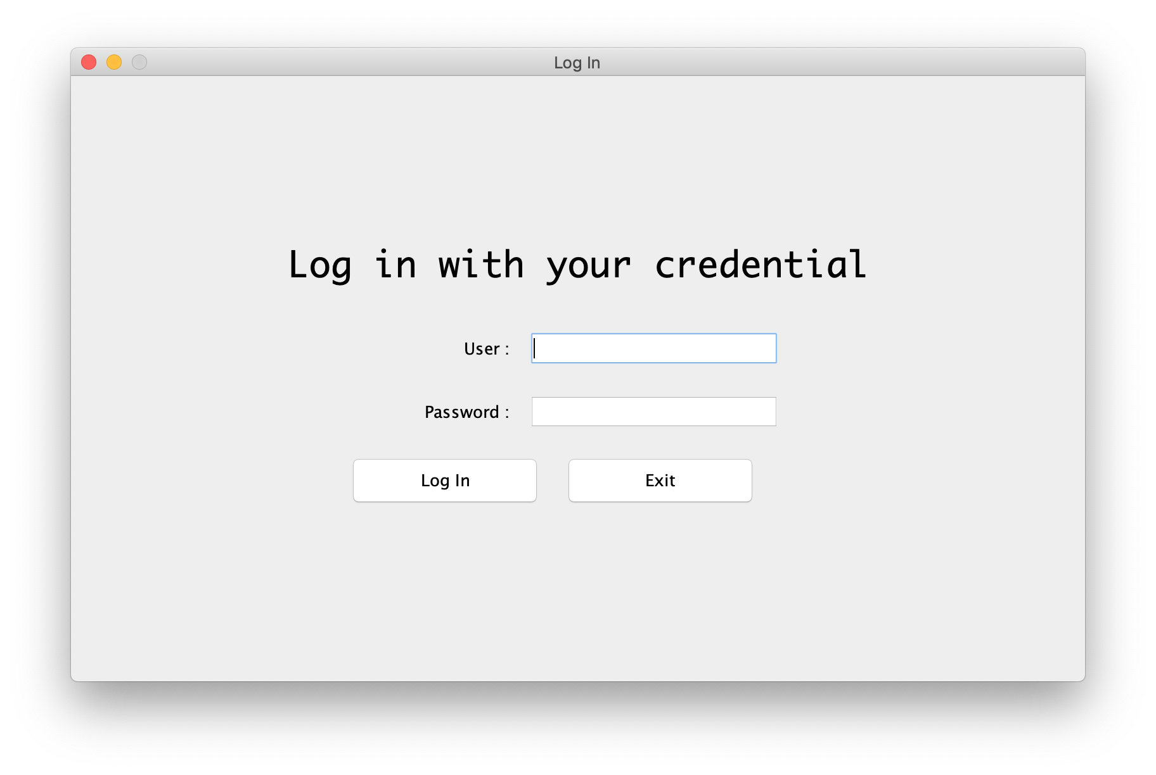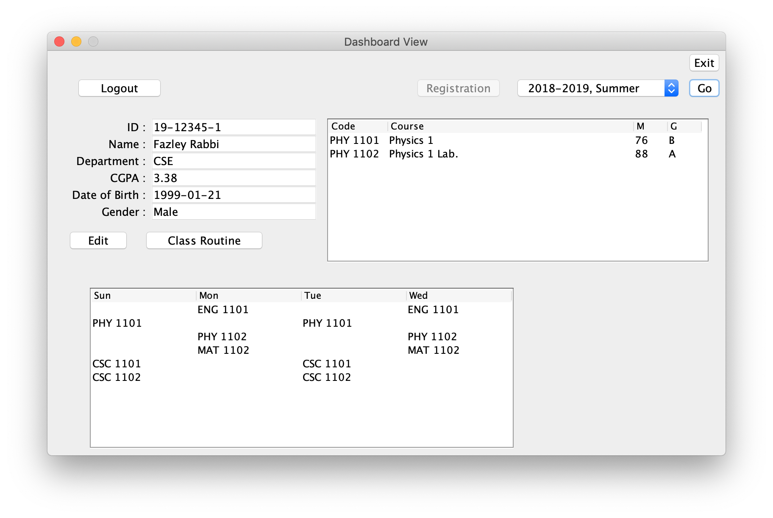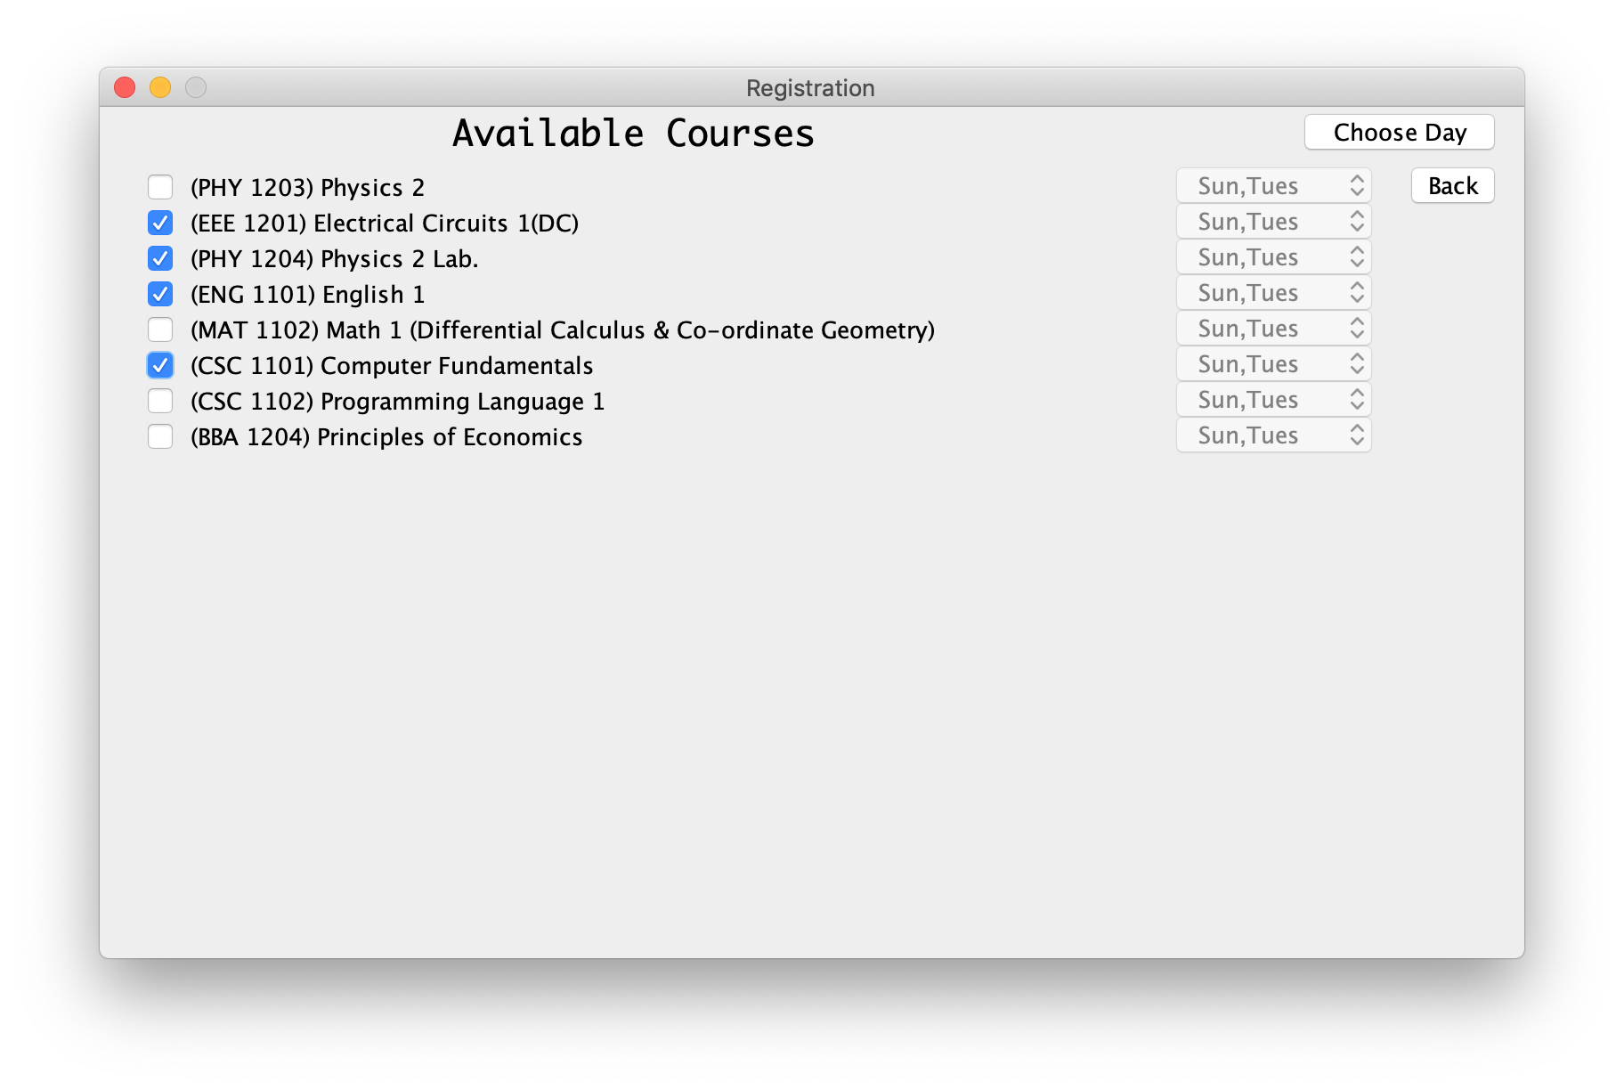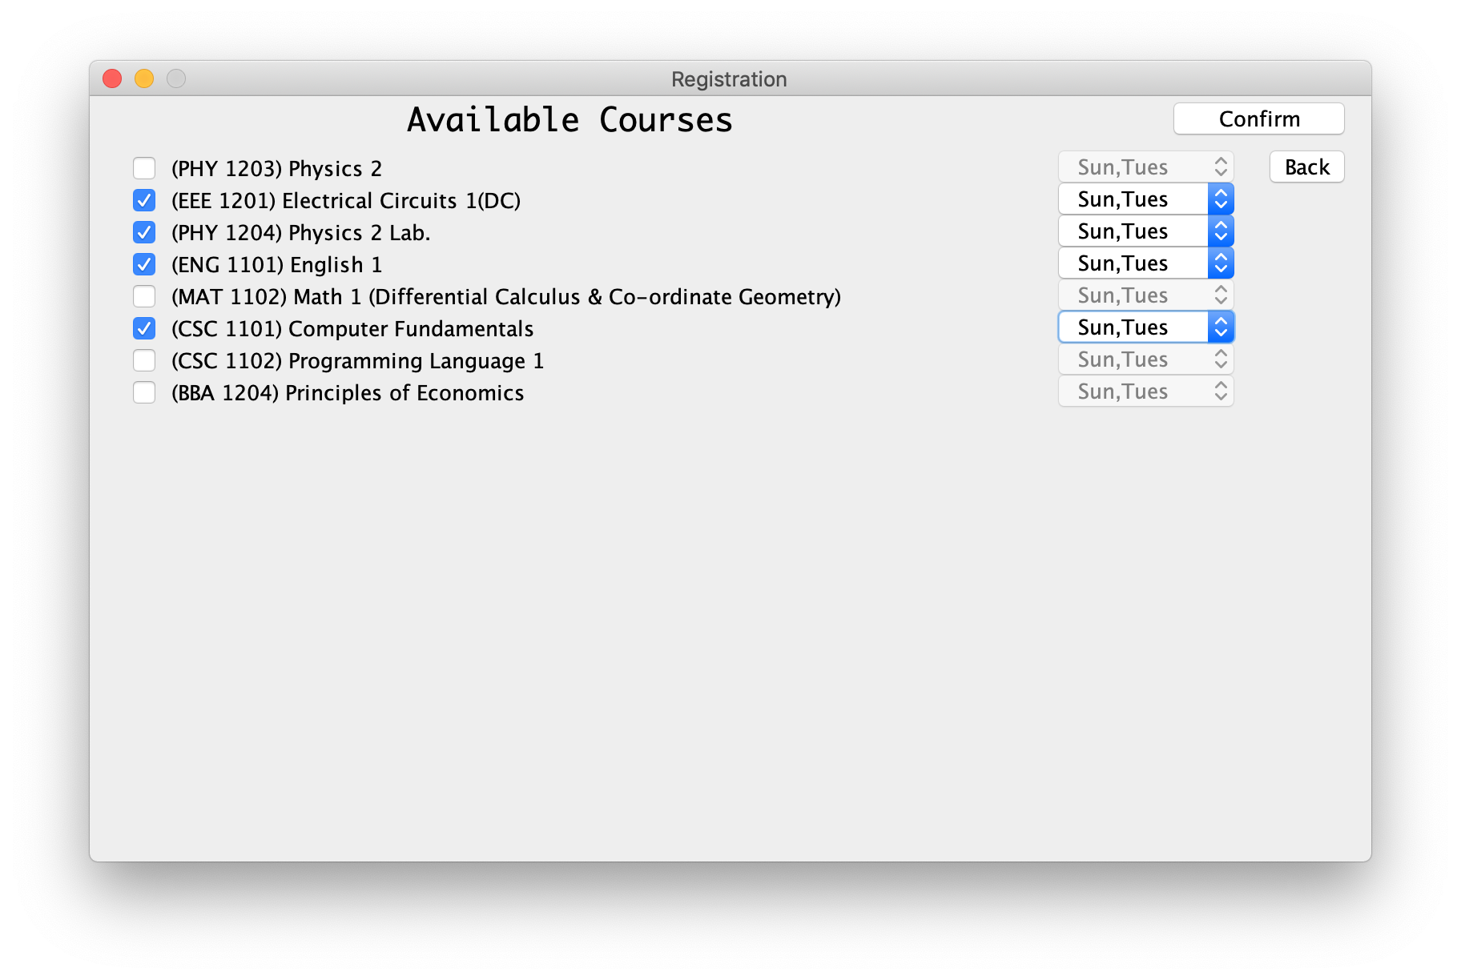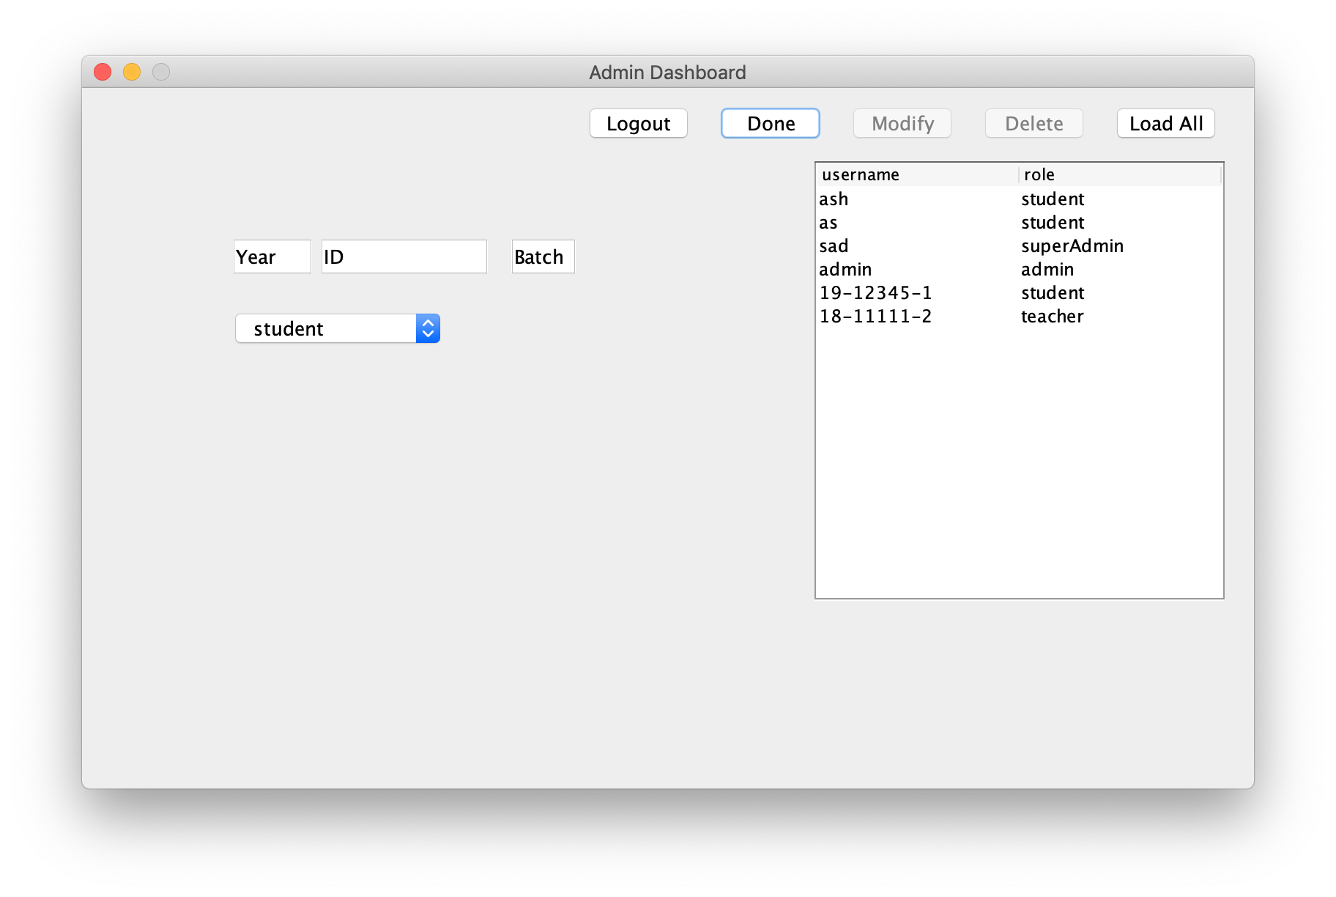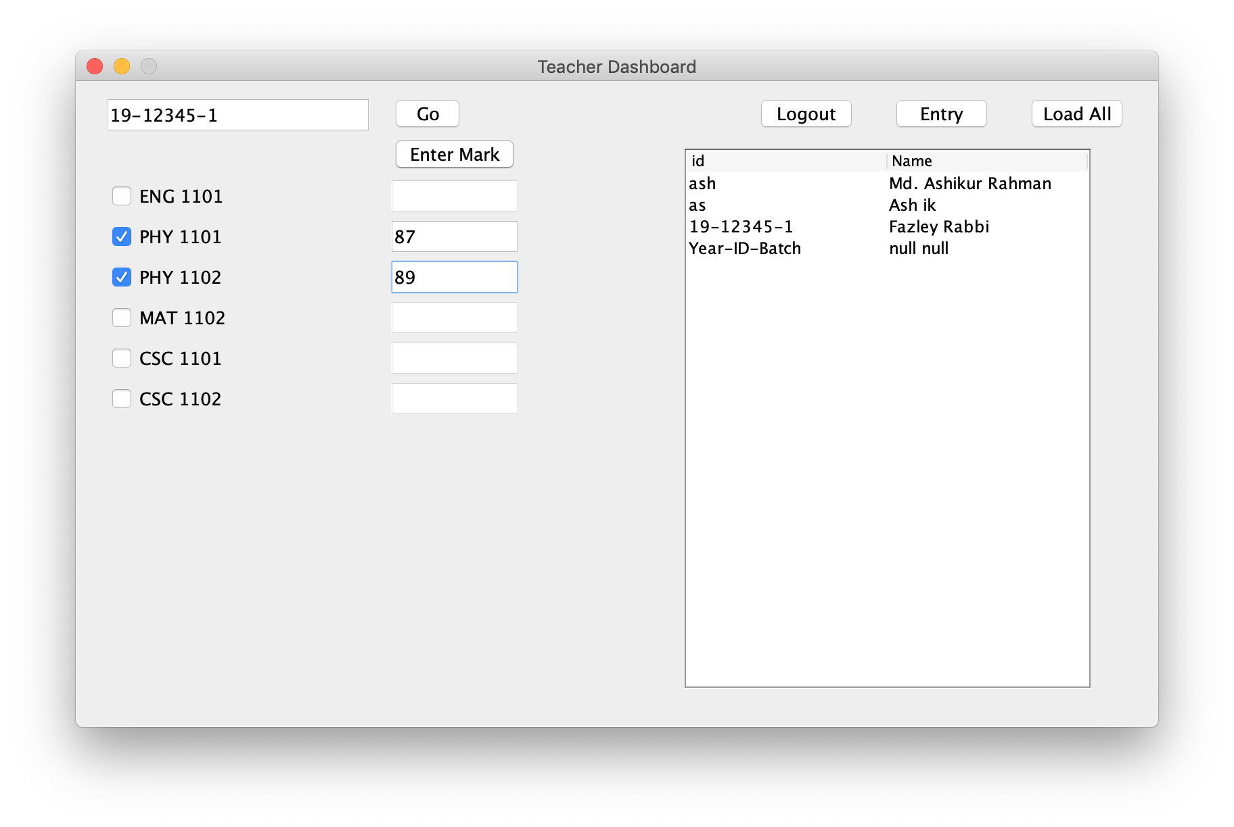

**Database Table Description:**

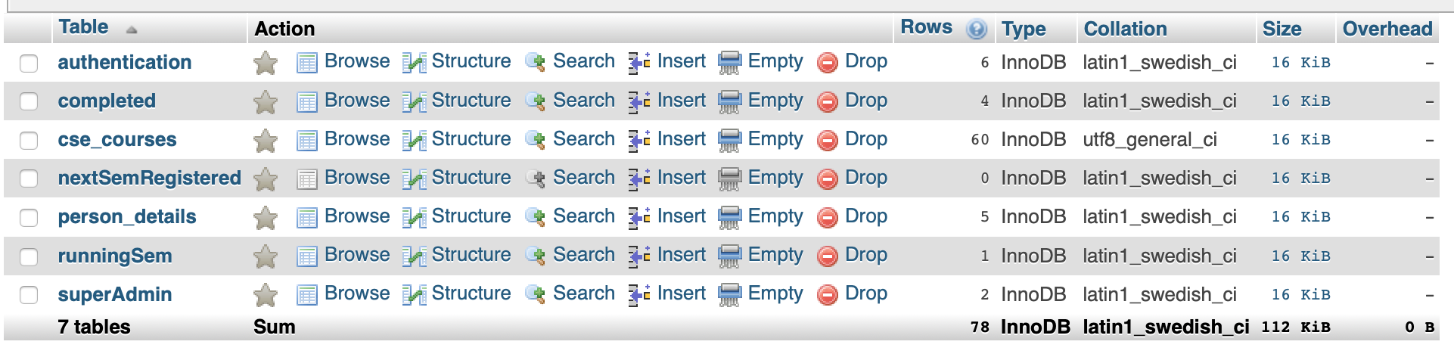

**Class Diagram:**

Draw a class diagram of your project here. You can draw then in a paper and add the image of the paper.

**Tools Used:**

To develop this project we have used the following:

* Visual Studio Code
* Java
* Bash Terminal

**OOP and Java Concepts Used:**

* Concept 1: Explain in no more than two sentences.
* Concept 2: Explain in no more than two sentences.
* .
* .
* .
* Concept N: Explain in no more than two sentences.

**Impact of this Project:**

What impact this project will have on the society and economy?

How will people be benefitted from your project?

(Maximum 80 words)

**Limitations and Possible Future Improvements:**

(Maximum 80 words)

***[Note: Make sure that your report is maximum 6 pages (including cover page). Print the report and do NOT even think of Spiral binding.]***